ASP.NET with C# LAB Manual

# PRACTICAL NO. : 01(A)

**AIM:** Write a console application that obtains four int values from the user and displays the product.

Hint: you may recall that the Convert.ToDouble() command was used to convert the input from the console to a double; the equivalent command to convert from a string to an int is Convert.ToInt32().

**CODE:**

using System;

namespace ConsoleApplication1

{

class Program

{

static void Main(string[] args)

{

int num1, num2,num3,num4,prod; Console.Write("Enter number 1: ");

num1 = Int32.Parse(Console.ReadLine()); Console.Write("Enter number 2: ");

num2 = Convert.ToInt32(Console.ReadLine()); Console.Write("Enter number 3: ");

num3 = Convert.ToInt32(Console.ReadLine()); Console.Write("Enter number 4: ");

num4 = Convert.ToInt32(Console.ReadLine()); prod = num1 * num2 * num3 * num4;

Console.WriteLine(num1 + "*" + num2 + "*" + num3 + "*" + num4 + "=" + prod);

}

}

}

**OUTPUT:**

Enter number 1: 6

Enter number 2: 5

Enter number 3: 4

Enter number 4: 3 6*5*4*3=360

# PRACTICAL NO. : 01(B)

**AIM:** If you have two integers stored in variables var1 and var2, what Boolean test can you perform to see if one or the other (but not both) is greater than 10?

**CODE:**

using System;

namespace ConsoleApplication2

{

class Program

{

static void Main(string[] args)

{

int var1, var2; Console.Write("Enter number 1: ");

var1 = Int32.Parse(Console.ReadLine()); Console.Write("Enter number 2: ");

var2 = Convert.ToInt32(Console.ReadLine());

if ((var1 > 10 && var2 <= 10) || (var2 > 10 && var1 <= 10))

{

Console.WriteLine("Boolean test succedded \n Both number are not >10");

}

}

}

}

**OUTPUT:**

Enter number 1: 5

Enter number 2: 11 Boolean test succedded Both number are not >10

**AIM:** Write an application that includes the logic from Exercise 1, obtains two numbers from the user, and displays them, but rejects any input where both numbers are greater than 10 and asks for two new numbers.

**CODE:**

using System;

namespace ConsoleApplication2

{

class Program

{

static void Main(string[] args)

{

int var1, var2; label1:

Console.Write("Enter number 1: ");

var1 = Int32.Parse(Console.ReadLine()); Console.Write("Enter number 2: ");

var2 = Convert.ToInt32(Console.ReadLine()); if ((var1 > 10 && var2 > 10) )

{

Console.WriteLine("Both No are greater than 10 are not allowed"); goto label1;

}

else

{

Console.WriteLine("Number 1: "+var1);

Console.WriteLine("Number 2 :"+var2);

}

}

}

}

**OUTPUT:**

Enter number 1:15

Enter number 2: 16

Both no. are greater than 10 are not allowed Enter number 1:5

Enter number 2: 15

Number 1: 5

Number 2 :15

# PRACTICAL NO. : 01(D)

**AIM:** Write a console application that places double quotation marks around each word in a string .

**CODE:**

using System;

namespace ConsoleApplication3

{

class Program

{

static void Main(string[] args)

{

string str1;

Console.Write("Enter string 1: "); str1 = Console.ReadLine(); string[] words = str1.Split(' ');

for (int i = 0; i < words.Length; i++)

{

Console.Write("\" " + words[i] + "\" ");

}

}

}

}

**OUTPUT:**

Enter string 1: we can and we will “we” “can” “and” “we” “will”

# PRACTICAL NO. : 01(E)

**AIM:** Write an application that uses two command-line arguments to place values into a string and an integer variable, respectively. Then display these values.

**CODE:**

using System; namespace cmdLineArgs

{

class Program

{

static void Main(string[] args)

{

string str = args[0];

int n = Convert.ToInt32(args[1]); Console.WriteLine("String:" + str); Console.WriteLine("Number:" + n);

}

}

}

**OUTPUT:**

String : Roman Number : 10

# PRACTICAL NO. : 01(F)

**AIM:** Write an application that receives the following information from a set of students: Student Id:

Student Name:

Course Name:

Date of Birth:

The application should also display the information of all the students once the data is Entered. Implement this using an Array of Structures.

**CODE:**

using System;

namespace ArrayOfStructs

{

class Program

{

struct Student

{

public string studid, name, cname; public int day, month, year;

}

static void Main(string[] args)

{

Student[] s = new Student[5]; int i;

for (i = 0; i < 5; i++)

{

Console.Write("Enter Student Id:"); s[i].studid = Console.ReadLine(); Console.Write("Enter Student name : "); s[i].name = Console.ReadLine(); Console.Write("Enter Course name : "); s[i].cname = Console.ReadLine();

Console.Write("Enter date of birth\n Enter day(1-31):"); s[i].day = Convert.ToInt32(Console.ReadLine()); Console.Write("Enter month(1-12):");

s[i].month = Convert.ToInt32(Console.ReadLine()); Console.Write("Enter year:");

s[i].year = Convert.ToInt32(Console.ReadLine());

}

Console.WriteLine("\n\nStudent's List\n"); for (i = 0; i < 5; i++)

{

Console.WriteLine("\nStudent ID : " + s[i].studid); Console.WriteLine("\nStudent name : " + s[i].name); Console.WriteLine("\nCourse name : " + s[i].cname); Console.WriteLine("\nDate of birth(dd-mm-yy) : " + s[i].day + "-" + s[i].month +

"-" + s[i].year);

} } } }

**OUTPUT:**

Enter Student Id:0001

Enter Student name : Prachit Enter Course name : MSCit Enter date of birth

Enter day(1-31):29 Enter month(1-12):9 Enter year:1995

Enter Student Id:0002

Enter Student name : Aniket Enter Course name : Bscit Enter date of birth

Enter day(1-31):4 Enter month(1-12):3 Enter year:1996

Enter Student Id:0003

Enter Student name : Prathamesh Enter Course name : BMS

Enter date of birth Enter day(1-31):9 Enter month(1-12):8 Enter year:2000

Enter Student Id:0004 Enter Student name : Sumit Enter Course name :MScet Enter date of birth

Enter day(1-31):25 Enter month(1-12):5 Enter year:1994

Enter Student Id : 0005 Enter Student name : Zaid Enter Course name : BCOM Enter date of birth

Enter day(1-31):6 Enter month(1-12):7 Enter year:1993

Student's List Student ID : 0001

Student name : Prachit Course name : MSCit

Date of birth(dd-mm-yy) : 29-9-1995 Student ID : 0002

Student name : Aniket Course name : Bscit

Date of birth(dd-mm-yy) : 4-3-1996 Student ID : 0003

Student name : Prathamesh Course name : BMS

Date of birth(dd-mm-yy) : 9-8-2000

Student ID : 0004 Student name : Sumit Course name : MScet

Date of birth(dd-mm-yy) : 25-5-1994 Student ID : 0005

Student name : Zaid Course name : BCOM

Date of birth(dd-mm-yy) : 6-7-1993

# PRACTICAL NO. : 01(G)

**AIM:** Write programs using conditional statements and loops:

1. Generate Fibonacci series.

**CODE:**

using System;

namespace ConsoleApplication3

{

class Program

{

static void Main(string[] args)

{

int num1=0,num2=1,num3,num4,num,counter; Console.Write ("Upto how many number you want fibonacci series:"); num=int.Parse(Console.ReadLine()); counter=3;

Console.Write(num1+"\t"+num2); while(counter<=num)

{

num3 = num1 + num2;

if (counter >= num)

break; Console.Write("\t" + num3); num1 = num2;

num2 = num3; counter++;

}

}

}

}

**OUTPUT:**

Upto how many number you want fibonacci series:5

0 1 1 2 3

# PRACTICAL NO. : 01(G)

**AIM:** Write programs using conditional statements and loops:

1. Generate various patterns (triangles, diamond and other patterns) with numbers.

**CODE -1:**

using System;

namespace ConsoleApplication1

{

class Program

{

static void Main(string[] args)

{

int row, col;

for (row = 1; row <= 5; row++)

{

for (col = 1; col <= row; col++) Console.Write(col);

Console.WriteLine();

}

}

}

}

**OUTPUT:**

1

12

123

1234

12345

**CODE -2:**

using System;

namespace ConsoleApplication1

{

class Program

{

static void Main(string[] args)

{

int row, sp, col;

for (row = 1; row <= 5; row++)

{

for (sp = 1; sp <= 5 - row; sp++)

{

Console.Write(' ');

}

for (col = 1; col <= row; col++)

{

}

}

} } } }

**OUTPUT:**

1

12

123

1234

12345

Console.Write(col); Console.WriteLine();

**CODE -3:**

using System;

namespace ConsoleApplication1

{

class Program

{

static void Main(string[] args)

{

int row, sp, col,revcol;

for (row = 1; row <= 5; row++)

{

for (sp = 1; sp <= 5 - row; sp++)

{

Console.Write(' ');

}

for (col = 1; col <= row; col++)

{

Console.Write(col);

}

for (revcol = col - 2; revcol >= 1; revcol--)

{

Console.Write(revcol);

}

Console.WriteLine();

}

}

}

}

**OUTPUT:**

1

121

12321

1234321

123454321

**CODE-4:**

using System;

namespace ConsoleApplication1

{

class Program

{

static void Main(string[] args)

{

int row, sp, col, revcol;

for (row = 1; row <= 5; row++) {

for (sp = 1; sp <= 5 - row; sp++)

{

Console.Write(' ');

}

for (col = 1; col <= row; col++)

{

Console.Write(col);

}

for (revcol = col - 2; revcol >= 1; revcol--)

{ Console.Write(revcol); } Console.WriteLine();

}

for (row = 4; row >= 1; row--) { for (sp = 1; sp <= 5 - row; sp++)

{

Console.Write(' ');

}

for (col = 1; col <= row; col++)

{

Console.Write(col);

}

for (revcol = col - 2; revcol >= 1; revcol--)

{ Console.Write(revcol); } Console.WriteLine();

} } } }

**OUTPUT:**

1

121

12321

1234321

123454321

1234321

12321

121

1

**CODE-5:**

using System; namespace pattern

{

class Program

{

static void Main(string[] args)

{

int row, col,sp,reverse;

for (row = 1; row <= 5; row++)

{

for (sp = 1; sp <= 5 - row; sp++) Console.Write(" ");

for (col = 1; col <= row; col++) if (col == 1)

Console.Write("*"); else

Console.Write(" ");

for (reverse = col - 2; reverse >= 1; reverse--) if (reverse == 1)

Console.Write("*"); else

Console.Write(" "); Console.WriteLine();

}

for (row = 4; row >=1; row--)

{

}

} } }

for (sp = 1; sp <= 5 - row; sp++) Console.Write(" ");

for (col = 1; col <= row; col++) if (col == 1)

Console.Write("*"); else

Console.Write(" ");

for (reverse = col - 2; reverse >= 1; reverse--) if (reverse == 1)

Console.Write("*"); else

Console.Write(" "); Console.WriteLine();

**OUTPUT:**

|  |  |
| --- | --- |
|  | * |
| * * | |
| * | * |
| * | * |
| * | * |
| * | * |
| * | * |

* *

*

# PRACTICAL NO. : 01(G)

**AIM:** Write programs using conditional statements and loops:

1. Test for prime numbers.

**CODE:**

using System; namespace testprime

{

class Program

{

static void Main(string[] args)

{

int num, counter; Console.Write("Enter number:"); num = int.Parse(Console.ReadLine());

for (counter = 2; counter <= num / 2; counter++)

{

if ((num % counter) == 0) break;

}

if (num == 1)

Console.WriteLine(num + "is neither prime nor composite"); else if(counter<(num/2))

Console.WriteLine(num+"is not prime number"); else

Console.WriteLine(num+"is prime number");

}

}

}

**OUTPUT:**

(1st attempt) Enter number:3

3 is prime number (2nd)

Enter number:1

1 is neither prime nor composite (3rd)

Enter number:4

4 is not prime number

# PRACTICAL NO. : 01(G)

**AIM:** Write programs using conditional statements and loops:

1. Generate prime numbers.

**CODE:**

using System; namespace testprime

{

class Program

{

static void Main(string[] args)

{

are ");

int counter, lowerlimit, upperlimit, limitCounter; Console.Write("Enter lowerlimit:"); lowerlimit = int.Parse(Console.ReadLine()); Console.Write("Enter upperlimit:"); upperlimit = int.Parse(Console.ReadLine());

Console.WriteLine("Prime number between " + lowerlimit + "and " + upperlimit + "

for (limitCounter = lowerlimit; limitCounter <= upperlimit; limitCounter++)

{

for (counter = 2; counter <= limitCounter / 2; counter++)

{

if ((limitCounter % counter) == 0) break;

}

}}}

if (limitCounter == 1)

Console.WriteLine(limitCounter + "is neither prime nor composite"); else if (counter >= (limitCounter / 2))

Console.WriteLine(limitCounter + "\t");

}

Console.WriteLine();

**OUTPUT:**

Enter lowerlimit:1 Enter upperlimit:15

Prime number between 1and 15 are 1is neither prime nor composite

2

3

4

5

7

11

13

**AIM:** Write programs using conditional statements and loops:

1. Reverse a number and find sum of digits of a number.

**CODE:**

using System;

namespace reverseNumber

{

class Program

{

static void Main(string[] args)

{

int num,actualnumber,revnum=0,digit,sumDigits=0; Console.Write("Enter number:"); num = int.Parse(Console.ReadLine());

actualnumber = num; while (num > 0)

{

digit = num % 10;

revnum = revnum * 10 + digit; sumDigits=sumDigits+digit; num = num / 10;

}

Console.WriteLine("Reverse of " + actualnumber + "=" + revnum); Console.WriteLine("Sum of its digits:" + sumDigits);

}

}

}

**OUTPUT:**

Enter number:15 Reverse of 15=51 Sum of its digits:6

**AIM:** Write programs using conditional statements and loops:

**V)** Test for vowels.

**CODE:**

using System; namespace vowels

{

class Program

{

static void Main(string[] args)

{

char ch;

Console.Write("Enter a character : "); ch = (char)Console.Read();

switch (ch)

{

case 'a':

case 'A':

case 'e':

case 'E':

case 'i':

case 'I':

case 'o':

case 'O':

case 'u':

case 'U':

Console.WriteLine(ch + "is vowel"); break;

default:

Console.Write(ch + "is not a vowel"); break;

}

Console.ReadKey();

}

}

}

**OUTPUT:**

Enter a character : a a is vowel

Enter a character : p p is not a vowel

**AIM:** Write programs using conditional statements and loops:

**VII)** Use of foreach loop with arrays.

**CODE:**

using System;

class ExampleForEach

{

public static void Main()

{

string[] str = { "Shield", "Evaluation", "DX" }; foreach (String s in str)

{

Console.WriteLine(s);

}

}

}

**OUTPUT:**

Shield Evaluation DX

# PRACTICAL NO. : 02(1)

**AIM:** Write a program to declare a class „staff‟ having data members as name and post.accept this data 5for 5 staffs and display names of staff who are HOD.

**CODE:**

using System; namespace staff

{

class staff

{

string name, post; public void getdata()

{

Console.Write("Enter name and post:"); name = Console.ReadLine();

post = Console.ReadLine();

}

public void display()

{

Console.WriteLine(name + "\t\t" + post);

}

public string getPost()

{

return post;

}

}

class program

{

static void Main(string[] args)

{

staff[] objStaff = new staff[5]; int i;

for (i = 0; i < 5; i++)

{

objStaff[i] = new staff(); objStaff[i].getdata();

}

Console.WriteLine("Name \t\t Post"); for (i = 0; i < 5; i++)

{

if (objStaff[i].getPost() == "HOD") objStaff[i].display();

}

}

}

}

**OUTPUT:**

Enter name and post:Prachit HOD

Enter name and post:Sumit PM

Enter name and post:Aniket HOD

Enter name and post:Prathamesh PM

Enter name and post:Zaid CA

Name Prachit Aniket

Post

HOD HOD

**AIM:** Write a program to declare class „Distance‟ have data members dist1,dist2 ,dist3. Initialize the two data members using constructor and store their addition in third data member using function and display addition.

**CODE:**

using System; namespace distanceclass

{

class Distance

{

int dist1,dist2,dist3;

public Distance(int dist1,int dist2)

{

this.dist1=dist1; this.dist2=dist2;

}

public void addition()

{

dist3=dist1+dist2;

}

public void display()

{

Console.WriteLine("Distance1:"+ dist1); Console.WriteLine("Distance1:"+ dist2); Console.WriteLine("Distance1:"+ dist3);

} }

class program

{

static void Main(string[] args)

{

Distance objDistance = new Distance(10, 20); objDistance.addition();

objDistance.display();

} } }

**OUTPUT:**

Distance1:10 Distance1:20 Distance1:30

**AIM:** Write a program using function overloading to swap two integer numbers and swap two float numbers.

**CODE:**

using System; namespace swap

{

class Overloading

{

public void swap(ref int n, ref int m)

{

int t; t = n;

n = m; m = t;

}

public void swap(ref float f1, ref float f2)

{

float f; f = f1; f1 = f2; f2 = f;

}

}

class program

{

static void Main(string[] args)

{

Overloading objOverloading = new Overloading(); int n = 10, m = 20;

objOverloading.swap(ref n, ref m); Console.WriteLine("N=" + n + "\tM=" + m); float f1 = 10.5f, f2 = 20.6f; objOverloading.swap(ref f1, ref f2); Console.WriteLine("F1=" + f1 + "\tF2=" + f2);

} } }

**OUTPUT:** N=20 M=10 F1=20.6 F2=10.5

# PRACTICAL NO. : 02(4)

**AIM:** Write a program to implement single inheritance from following figure. Accept and display data for one table.

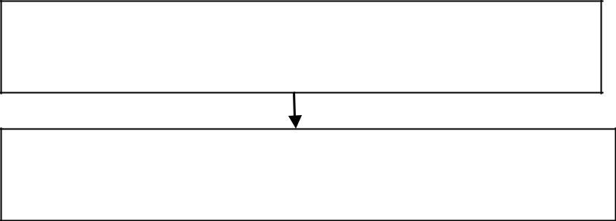

Class Furniture

Data Members : material ,price

Class Table

Data Members : Height ,surface_area

**CODE:**

## Furniture.cs

using System;

namespace SingleInheritance

{

class Furniture

{

string material; float price;

public void getdata()

{

Console.Write("Enter material : "); material = Console.ReadLine(); Console.Write("Enter price : ");

price = float.Parse(Console.ReadLine());

}

public void showdata()

{

Console.WriteLine("Material : " + material); Console.WriteLine("Price : " + price);

} } }

## Table.cs

using System;

namespace SingleInheritance

{

class Table:Furniture

{

int height, surface_area; public void getdata()

{

base.getdata(); Console.Write("Enter height: ");

height = int.Parse(Console.ReadLine()); Console.Write("Enter surface area: ");

surface_area = int.Parse(Console.ReadLine());

}

public void showdata()

{

base.showdata(); Console.WriteLine("Height : " + height);

Console.WriteLine("Surface Area : " + surface_area);

} } }

## Program.cs

using System;

namespace SingleInheritance

{

class Program

{

static void Main(string[] args)

{

Table t1 = new Table(); t1.getdata(); t1.showdata();

} } }

**OUTPUT:**

Enter material : wood Enter price : 1220 Enter height: 35 Enter surface area: 26 Material : wood

Price : 1220

Height : 35 Surface Area : 26

# PRACTICAL NO. : 02(5)

**AIM:** Define a class „salary‟ which will contain member variable Basic, TA, DA, HRA. Write a program using Constructor with default values for DA and HRA and calculate the salary of employee.

**CODE:**

## Salary.cs

using System;

namespace SalaryConstructure

{

class Salary

{

int basic, ta, da, hra; public Salary()

{

da = 9000;

hra = 6000;

}

public void getdata()

{

Console.Write("Enter basic salary : "); basic = int.Parse(Console.ReadLine()); Console.Write("Enter travelling allowance : "); ta = int.Parse(Console.ReadLine());

}

public void showdata()

{

Console.WriteLine("Basic salary : " + basic); Console.WriteLine("Dearness allowence : " + da); Console.WriteLine("Housing rent allowence : " + hra); Console.WriteLine("Travelling allowence : " + ta); Console.WriteLine("Gross Salary : " + (basic + da + hra + ta));

} } }

## Program.cs

using System;

namespace SalaryConstructure

{

class Program

{

static void Main(string[] args)

{

Salary s = new Salary(); s.getdata();

s.showdata();

} } }

**OUTPUT:**

Enter basic salary : 52000

Enter travelling allowance : 3000 Basic salary : 52000

Dearness allowence : 9000 Housing rent allowence : 6000 Travelling allowence : 3000 Gross Salary : 70000

# PRACTICAL NO. : 02(6)

**AIM**: Program to implement the following multiple inheritance using interface.

|  |  |  |
| --- | --- | --- |
| Interface: Gross |  | Class : Employee |
| TA,DA ,Gross_sal() |  | name, basic_sal() |

**CODE:**

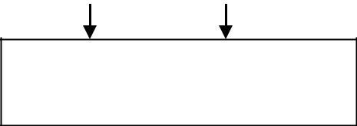

Class : salary Disp_sal(),HRA

## Gross.cs

using System;

namespace MultipleInheritance

{

interface Gross

{

int ta

{

get; set;

}

int da

{

get; set;

}

int GrossSal();

} }

## Employee.cs

using System;

namespace MultipleInheritance

{

class Employee

{

string name;

public Employee(string name)

{ this.name = name; } public int BasicSal(int basicSal) { return basicSal; }

public void ShowData()

{

Console.WriteLine("Name : " + name);

} } }

## Salary.cs

using System;

namespace MultipleInheritance

{

class Salary:employee,Gross

{

int hra;

public Salary(string name, int hra):base(name)

{ this.hra = hra; } public int ta

{

get {return S_ta; } set { S_ta = value; }

}

private int S_ta; public int da

{

get { return S_da; } set { S_da = value; }

}

private int S_da; public int GrossSal()

{

int gSal;

gSal = hra + ta + da + BasicSal(15000); return gSal;

}

public void dispSal()

{ base.ShowData();

Console.WriteLine("Gross Sal : " + GrossSal());

} } }

## Program.cs

using System;

namespace MultipleInheritance

{

class Program

{

static void Main(string[] args)

{

Salary s = new Salary("Prachit", 35000); s.da = 20000;

s.ta = 30000;

s.dispSal();

} } }

**OUTPUT:**

Name :Prachit Gross Sal :100000

# PRACTICAL NO. : 02(7)

**AIM**: Write a program for above class hierarchy for the Employee where the base class is Employee and derived class and Programmer and Manager. Here make display function virtual which is common for all and which will display information of Programmer and Manager interactively.

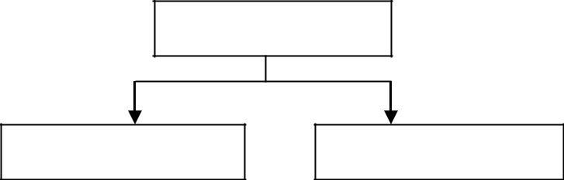

Employee

Programmer

Manager

**CODE:**

## Employee.cs

using System;

namespace HeirarchicalInheritance

{

class employee

{

public virtual void display()

{

Console.WriteLine("Display of employee class called ");

} } }

## Programmer.cs

using System;

namespace HeirarchicalInheritance

{

class Programmer:employee

{

public void display()

{

Console.WriteLine(" Display of Programmer class called ");

} } }

## Manager.cs

using System;

namespace HeirarchicalInheritance

{

class Manager

{

public void display()

{

Console.WriteLine("Display of manager class called ");

} } }

## Program.cs

using System;

namespace HeirarchicalInheritance

{

class Program

{

static void Main(string[] args)

{

Programmer objProgrammer; Manager objManager;

Console.Write("Whose details you want to use to see \n 1.Programmer

\n 2.Manager");

int choice=int.Parse(Console.ReadLine()); if(choice==1)

{

objProgrammer=new Programmer(); objProgrammer.display();

}

else if(choice==2)

{

objManager=new Manager(); objManager.display();

}

else

{

Console.WriteLine("Wrong choice entered");

} } } }

**OUTPUT:**

Whose details you want to use to see

1. Programmer
2. Manager1

Display of Programmer class called

Whose details you want to use to see

1. Programmer
2. Manager2

Display of manager class called

Whose details you want to use to see

1. Programmer
2. Manager6

Wrong choice entered

# PRACTICAL NO. : 02(8)

**AIM**: Write a program to implement multilevel inheritance from following figure. Accept and display data for one student.

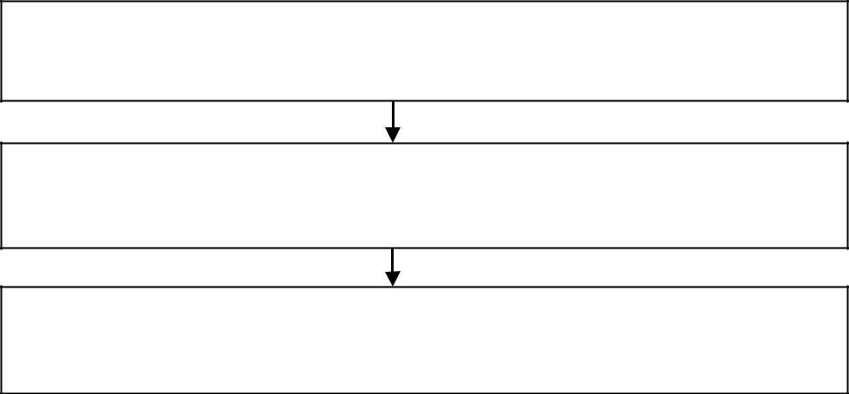

Class student

Data Members : Roll_no , name

Class Test

Data Members : marks1 , marks2

Class Result

Data Members : total

**CODE:**

## Result.cs

using System;

namespace multilevelinheritance

{

class Result:Test

{

int total;

public Result(int roll_no, string name, int marks1, int marks2)

: base(roll_no, name, marks1, marks2)

{

total = getMarks1() + getMarks2();

}

public void display()

{

base.display(); Console.WriteLine("Total: " + total);

} } }

## Test.cs

using System;

namespace multilevelinheritance

{

class Test:student

{

int marks1, marks2;

public Test(int roll_no, string name, int marks1, int marks2)

: base(roll_no, name)

{

this.marks1 = marks1; this.marks2 = marks2;

}

public int getMarks1()

{

return marks1;

}

public int getMarks2()

{

return marks2;

}

public void dispaly()

{

base.display(); Console.WriteLine("Marks1: " + marks1); Console.WriteLine("Marks2: " + marks2);

} } }

## Student.cs

using System;

namespace multilevelinheritance

{

class student

{

int roll_no; string name;

public student(int roll_no, string name)

{

this.roll_no = roll_no; this.name = name;

}

public student() { } public void display()

{

Console.WriteLine("Roll no: " + roll_no); Console.WriteLine("Name: " + name);

} } }

## Program.cs

using System;

namespace multilevelinheritance

{

class Program

{

static void Main(string[] args)

{

Result r1 = new Result(101, "Prachit", 50, 70); r1.display();

} } }

**OUTPUT:**

Roll no: 101 Name: Prachit Marks1: 50

Marks2: 70

Total: 120

# PRACTICAL NO. : 02(9)

**AIM**: Write a program to create a delegate called TrafficDel and a class called TrafficSignal with the following delegate methods.

Public static void Yellow()

{

Console.WriteLine(“Yellow Light Signal To Get Ready”);

}

Public static void Green()

{

Console.WriteLine(“Green Light Signal To Go”);

}

Public static void Red()

{

Console.WriteLine(“Red Light Signal To Stop”);

}

Also include a method IdentifySignal() to initialize an array of delegate with the above methods and a method show() to invoke members of the above array.

**CODE:**

## TrafficSignal.cs

using System;

namespace TrafficDelegateExample

{

public delegate void TrafficDel(); class TrafficSignal

{

public static void Yellow()

{

Console.WriteLine("Yellow light signals to get ready");

}

public static void Green()

{

Console.WriteLine("Green light signals to go");

}

public static void Red()

{

Console.WriteLine("Red light signals to stop");

}

TrafficDel[] td = new TrafficDel[3]; public void IdentifySignal()

{

td[0] = new TrafficDel(Yellow); td[1] = new TrafficDel(Green);

td[2] = new TrafficDel(Red);

}

public void display()

{

td[0]();

td[1]();

td[2]();

}

} }

## Program.cs

using System;

namespace TrafficDelegateExample

{

class Program

{

static void Main(string[] args)

{

TrafficSignal ts = new TrafficSignal(); ts.IdentifySignal();

ts.display();

} } }

**OUTPUT:**

Yellow light signals to get ready Green light signals to go

Red light signals to stop

**AIM**: Write a program to accept a number from the user and throw an exception if the number is not an even number.

**CODE:**

## NotEvenException.cs

using System;

namespace ExceptionHandlingExample

{

class NotEvenException:Exception

{

public NotEvenException(string msg)

: base(msg)

{

}

} }

## Program.cs

using System;

namespace ExceptionHandlingExample

{

class Program

{

static void Main(string[] args)

{

int num; try

{

Console.Write("Enter a number: "); num = int.Parse(Console.ReadLine());

if ((num % 2) != 0) throw new NotEvenException("Not an even number "); else

Console.WriteLine("Its even number ");

}

catch (NotEvenException e) { Console.WriteLine(e.Message); }

} } }

**OUTPUT:**

Enter a number: 5 Not an even number

Enter a number: 6 Its even number

# PRACTICAL NO. : 03(1)

**AIM**: Create an application that allows the user to enter a number in the textbox named

„getnum‟. Check whether the number in the textbox „getnum‟ is palindrome or not. Print the message accordingly in the label control named lbldisplay when the user clicks on the button

„check‟.

**DESIGN:**

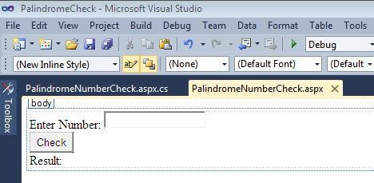

**PROPERTIES TABLE:**

|  |  |  |
| --- | --- | --- |
| **Control** | **Property** | **Value** |
| Label1 | Text | Enter Number |
|  | ID | lblnum1 |
| TextBox | ID | getNum |
| Button | Text | Check |
|  | ID | btncheck |
| Label2 | Text | Result |
|  | ID | lblnum2 |

**CODE:**

using System.Web; using System.Web.UI;

using System.Web.UI.WebControls; namespace PalindromeCheck

{

public partial class PalindromeNumberCheck : System.Web.UI.Page

{

protected void Page_Load(object sender, EventArgs e)

{

}

protected void btncheck_Click(object sender, EventArgs e)

{

int num = int.Parse(getNum.Text); int n, rev = 0, d;

n = num; while (n > 0)

{

d = n % 10;

n = n / 10;

rev = rev * 10 + d;

}

if (rev == num)

lblnum2.Text = lblnum2.Text + num + " is a Palindrome number."; else

lblnum2.Text = lblnum2.Text + num + " is not a Palindrome number.";

} } }

**BROWSER OUTPUT:**

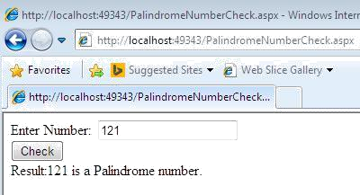

# PRACTICAL NO. : 03(2)

**AIM**: Create an application which will ask the user to input his name and a message, display the two items concatenated in a label, and change the format of the label using radio buttons and check boxes for selection , the user can make the label text bold ,underlined or italic and change its color . include buttons to display the message in the label, clear the text boxes and label and exit.

**DESIGN:**

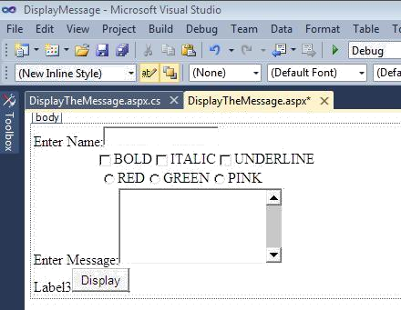

**PROPERTIES TABLE:**

|  |  |  |
| --- | --- | --- |
| **Control** | **Property** | **Value** |
| Label1 | ID | lbl1 |
|  | Text | Enter Name |
| Checkbox1 | ID | chkbold |
|  | Text | BOLD |
| Checkbox2 | ID | chkitalic |
|  | Text | ITALIC |
| Checkbox3 | ID | chkunderline |
|  | Text | UNDERLINE |
| RadioButton1 | ID | rbred |
|  | Text | RED |
| RadioButton2 | ID | rbgreen |
|  | Text | GREEN |
| RadioButton3 | ID | rbpink |
|  | Text | PINK |
| Label2 | ID | txtmessage |
|  | Text | Enter Message |
| Button | ID | btndisplay |
|  | Text | Display |
| Label3 | ID | lblDisplay |
|  | Text | Label3 |
| 42 | | |

**CODE:**

using System;

namespace DisplayMessage

{

public partial class DisplayTheMessage : System.Web.UI.Page

{

protected void Page_Load(object sender, EventArgs e)

{

}

protected void btndisplay_Click(object sender, EventArgs e)

{

if (chkbold.Checked == true) lblDisplay.Font.Bold = true;

else

lblDisplay.Font.Bold = false;

if (chkitalic.Checked == true) lblDisplay.Font.Italic = true;

else

lblDisplay.Font.Italic = false;

if (chkunderline.Checked == true) lblDisplay.Font.Underline = true;

else

lblDisplay.Font.Underline = false; if (rbred.Checked == true)

lblDisplay.ForeColor = System.Drawing.Color.Red; else if(rbgreen.Checked == true)

lblDisplay.ForeColor = System.Drawing.Color.Green; else if (rbpink.Checked == true)

lblDisplay.ForeColor = System.Drawing.Color.Pink; lblDisplay.Text = "Name:" + txtName.Text + "<br/>" + "Message:" +

txtMessage.Text;

} } }

**BROWSER OUTPUT:**

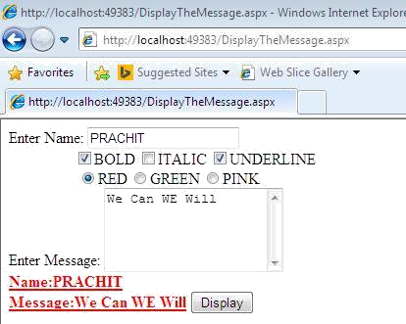

# PRACTICAL NO. : 03(3)

**AIM**: List of employees is available in listbox. Write an application to add selected or all records from listbox (assume multi-line property of textbox is true).

**DESIGN:**

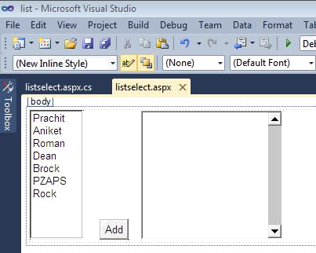

**PROPERTIES TABLE:**

**CODE:**

using System; namespace list

{

public partial class listselect : System.Web.UI.Page

{

protected void Page_Load(object sender, EventArgs e)

{

}

protected void btnAdd_Click(object sender, EventArgs e)

{

int i;

for (i = 0; i < lstEmployee.Items.Count; i++)

{

if (lstEmployee.Items[i].Selected == true) txtEmployee.Text

+= lstEmployee.Items[i].Text + "\n";

}

} } }

**BROWSER OUTPUT:**

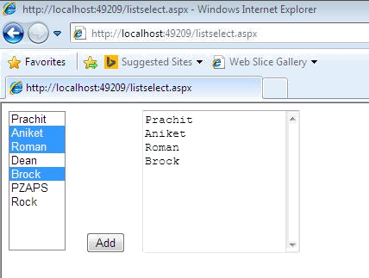

# PRACTICAL NO. : 03(4)

**AIM**: “How is the book ASP.NET with c# by Vipul Prakashan?” Give the user three choice :

i)Good ii)Satisfactory iii)Bad. Provide a VOTE button. After user votes, present the result in percentage using labels next to the choices.

**DESIGN:**

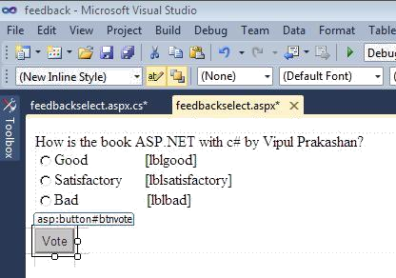

**PROPERTIES TABLE:**

|  |  |  |
| --- | --- | --- |
| **Control** | **Property** | **Value** |
| Label1 | ID | lbltxt1 |
|  | Text | How is the Book ASP.NET |
| with c# Vipul Prakashan |
| RadioButton1 | ID | rdogood |
|  | Text | Good |
| RadioButton2 | ID | rdosatisfactory |
|  | Text | Satisfactory |
| RadioButton3 | ID | rdobad |
|  | Text | Bad |
| Label2 | ID | lblgood |
|  | Text |  |
| Label3 | ID | lblsatisfactory |
|  | Text |  |
| Label4 | ID | lblbad |
|  | Text |  |
| Button | ID | btnvote |
|  | Text | Vote |
|  |  |  |

**CODE:**

using System; namespace feedback

{

public partial class feedbackselect : System.Web.UI.Page

{

protected void Page_Load(object sender, EventArgs e)

{

}

protected void btnvote_Click(object sender, EventArgs e)

{

if (rdogood.Checked == true)

{

int goodCount;

if (ViewState["gcount"] != null)

goodCount = Convert.ToInt32(ViewState["gcount"]) + 1; else

goodCount = 1; ViewState["gcount"] = goodCount;

}

if (rdosatisfactory.Checked == true)

{

int satisfactoryCount;

if (ViewState["scount"] != null)

satisfactoryCount = Convert.ToInt32(ViewState["scount"]) + 1; else

satisfactoryCount = 1; ViewState["scount"] = satisfactoryCount;

}

if (rdobad.Checked == true)

{

int badCount;

if (ViewState["bcount"] != null)

badCount = Convert.ToInt32(ViewState["bcount"]) + 1; else

badCount = 1; ViewState["bcount"] = badCount;

}

int totalCount;

if (ViewState["count"] != null)

totalCount = Convert.ToInt32(ViewState["count"]) + 1; else

totalCount = 1; ViewState["count"] = totalCount;

double gper = (Convert.ToDouble(ViewState["gcount"]) / Convert.ToDouble(ViewState["count"])) * 100.0f;

lblgood.Text = gper.ToString() + "%";

double sper = (Convert.ToDouble(ViewState["scount"])

/ Convert.ToDouble(ViewState["count"])) * 100.0f; lblsatisfactory.Text = sper.ToString() + "%";

double bper = (Convert.ToDouble(ViewState["bcount"]) / Convert.ToDouble(ViewState["count"])) * 100.0f;

lblbad.Text = bper.ToString()+"%";

} } }

**BROWSER OUTPUT:**

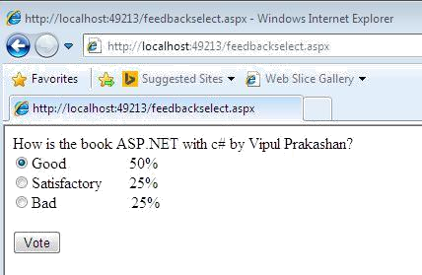

# PRACTICAL NO. : 03(5)

**AIM**: Create a project that calculates the total of fat, carbohydrate and protein. Allow the user to enter into text boxes. The grams of fat, grams of carbohydrate and grams of protein. Each gram of fat is 9 calories and protein or carbohydrate is 4 calories. Display the total calories of the current food item in a label. Use to other labels to display and accumulated some of calories and the count of items entered. The form food have 3 text boxes for the user to enter the grams for each category include label next to each text box indicating what the user is enter.

**DESIGN:**

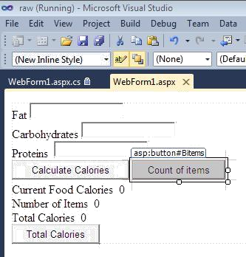

**PROPERTIES TABLE:**

**CODE:**

using System; namespace raw

{

public partial class WebForm1 : System.Web.UI.Page

{

protected void Page_Load(object sender, EventArgs e)

{

}

int curr_cal, total_cal, total_items;

protected void Bcalories_Click(object sender, EventArgs e)

{

curr_cal = (Convert.ToInt32(txtfat.Text) * 9 + Convert.ToInt32(txtcarbo.Text) * 4 + Convert.ToInt32(txtpro.Text) * 4);

lblcfc.Text = Convert.ToString(curr_cal); lblnof.Text = Convert.ToString(total_cal);

lbltc.Text = Convert.ToString(total_items);

}

protected void Bitems_Click(object sender, EventArgs e)

{

lblnof.Text = Convert.ToString(Convert.ToInt32(lblnof.Text) + 1);

}

protected void Btotalcalo_Click(object sender, EventArgs e)

{

lbltc.Text = Convert.ToString(Convert.ToInt32(lbltc.Text) + Convert.ToInt32(lblcfc.Text));

}

} }

**BROWSER OUTPUT:**

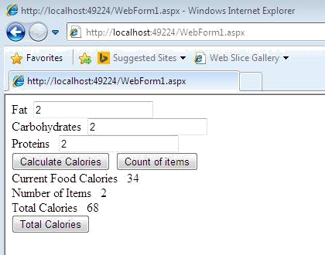

# PRACTICAL NO. : 04(1)

**AIM**: Set the label border color of rollno to red using css.

**DESIGN:**

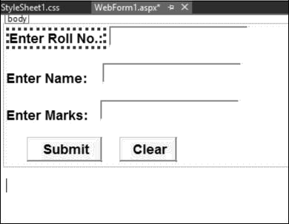

**PROPERTY TABLE :**

|  |  |  |
| --- | --- | --- |
| **Control** | **Property** | **Value** |
| Label1 | ID | lblRollNo |
| Label1 | Text | Enter Roll No. |
| Label1 | BorderStyle | Dotted |
| Label1 | BackColor | Coral |
| Label2 | ID | lblName |
| Label2 | Text | Enter Name |
| Label3 | ID | lblMarks |
| Label3 | Text | Enter Marks |
| TextBox1 | ID | txtRollNo |
| TextBox2 | ID | txtName |
| TextBox3 | ID | txtMarks |
| Button1 | ID | btnSubmit |
| Button1 | Text | Submit |

**CODE:**

Page Language="C#" AutoEventWireup="true"

<%@

CodeBehind="cssexample.aspx.cs" Inherits="practical4css.cssexample" %>

<!DOCTYPE html PUBLIC "-//W3C//DTD XHTML 1.0 Transitional//EN" "[http://www.w3.org/TR/xhtml1/DTD/xhtml1-transitional.dtd"](http://www.w3.org/TR/xhtml1/DTD/xhtml1-transitional.dtd)>

<html xmlns="<http://www.w3.org/1999/xhtml>">

<head runat="server">

<title></title>

</head>

<body>

<form id="form1" runat="server">

<div>

<asp:Label ID="Label1" runat="server" Text="Enter Roll No.:"

**BorderStyle="Dotted" BackColor="Coral"**></asp:Label>

<asp:TextBox ID="TextBox1" runat="server"></asp:TextBox>

<br />

<asp:Label ID="Label2" runat="server" Text="Enter Name:"></asp:Label> <asp:TextBox ID="TextBox2" runat="server"></asp:TextBox> <br />

<asp:Label ID="Label3" runat="server" Text="Enter Marks:"></asp:Label> <asp:TextBox ID="TextBox3" runat="server"></asp:TextBox> <br />

<br />

<asp:Button ID="Button1" runat="server" Text="Submit" /> &nbsp;&nbsp;&nbsp;&nbsp;&nbsp;&nbsp;&nbsp;&nbsp;&nbsp;&nbsp;&nbsp;

<asp:Button ID="Button2" runat="server" Text="Clear" />

</div>

</form>

</body>

</html>

**BROWSER OUTPUT:**

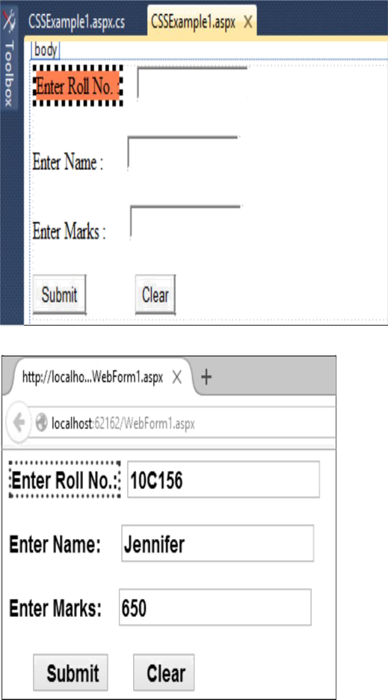

# PRACTICAL NO. : 04(2)

**AIM**: Set the font-Arial , font style-bond , font size-18px of different controls(ie. Label, textbox, button) using css.

**DESIGN:**

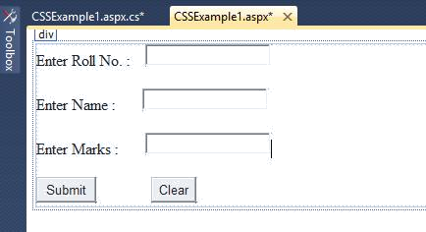

**PROPERTY TABLE :**

|  |  |  |
| --- | --- | --- |
| **Control** | **Property** | **Value** |
| Label1 | ID | lblRollNo |
| Label1 | Text | Enter Roll No. |
| Label1 | BorderStyle | Dotted |
| Label1 | BackColor | Coral |
| Label2 | ID | lblName |
| Label2 | Text | Enter Name |
| Label2 | CssClass | Common |
| Label3 | ID | lblMarks |
| Label3 | Text | Enter Marks |
| Label3 | CssClass | Common |
| TextBox1 | ID | txtRollNo |
| TextBox1 | CssClass | Txt Style |
| TextBox2 | ID | txtName |
| TextBox2 | CssClass | Txt Style |
| TextBox3 | ID | txtMarks |
| TextBox3 | CssClass | Txt Style |
| Button1 | ID | btnSubmit |
| Button1 | Text | Submit |
| Button1 | CssClass | btnStyle |
| Button2 | ID | btnClear |
| Button2 | Text | Clear |
| Button2 | CssClass | btnStyle |

**CODE:**

## Myformat.css

.BtnStyle

{

font-family:Times New Roman; font-size:large;

font-weight:bold;

}

.TxtStyle

{

font-family:Georgia; font-size:larger;

font-weight:400; background-color:Maroon; border:2px solid goldenrod;

}

.Common

{

background-color:Aqua; color:Red;

font-family:Courier New; font-size:20px;

font-weight:bolder;

}

## Myformatting.aspx

<%@ Page Language="C#" AutoEventWireup="true" CodeBehind="cssexample.aspx.cs" Inherits="practical4css.cssexample" %>

<!DOCTYPE html PUBLIC "-//W3C//DTD XHTML 1.0 Transitional//EN" "<http://www.w3.org/TR/xhtml1/DTD/xhtml1-transitional.dtd>">

<html xmlns="<http://www.w3.org/1999/xhtml>">

<head runat="server">

<title></title>

<body>

<form id="form1" runat="server">

<div>

<asp:Label ID="Label1" runat="server" Text="Enter Roll No.:" BorderStyle="Dotted" BackColor="Coral"></asp:Label>

<asp:TextBox ID="TextBox1" runat="server" CssClass="TxtStyle"></asp:TextBox> <br />

<asp:Label ID="Label2" runat="server" Text="Enter Name:" CssClass="Common"></asp:Label>

<asp:TextBox ID="TextBox2" runat="server" CssClass="TxtStyle"></asp:TextBox> <br />

<asp:Label ID="Label3" runat="server" Text="Enter Marks:" CssClass="Common"></asp:Label>

<asp:TextBox ID="TextBox3" runat="server" CssClass="TxtStyle"></asp:TextBox>

<br />

<br />

<asp:Button ID="Button1" runat="server" Text="Submit" CssClass="BtnStyle" />

<asp:Button ID="Button2" runat="server" Text="Clear" CssClass="BtnStyle" />

</div>

</form>

</body>

</html>

**BROWSER OUTPUT:**

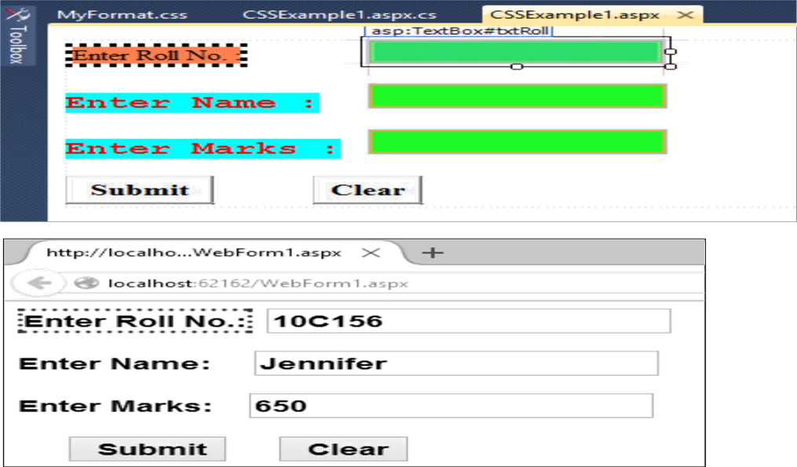

# PRACTICAL NO. : 04(3)

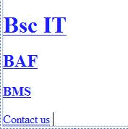**AIM**: Design the same webpages for BMS, BAF, BscIT students and apply same background color for all the pages using css.

**PROPERTY TABLE :**

|  |  |  |
| --- | --- | --- |
| **Control** | **Property** | **Value** |
| Label1 | ID | lblBScIT |
| Label1 | Text | Welcome to BScIT |
| Label1 | CssClass | bk |

|  |  |  |
| --- | --- | --- |
| **Control** | **Property** | **Value** |
| Label1 | ID | lblBAF |
| Label1 | Text | Welcome to BMS |
| Label1 | CssClass | bk |

|  |  |  |
| --- | --- | --- |
| **Control** | **Property** | **Value** |
| Label1 | ID | lblBMS |
| Label1 | Text | Welcome to BAF |
| Label1 | CssClass | bk |

**CODE:**

## Myformat.css

.BtnStyle

{

font-family:Times New Roman; font-size:large;

font-weight:bold;

}

.TxtStyle

{

font-family:Georgia; font-size:larger;

font-weight:400; background-color:Lime; border:2px solid goldenrod;

}

.Common

{

background-color:Aqua; color:Red;

font-family:Courier New; font-size:20px;

font-weight:bolder;

}

## .bk

**{**

## background-color:Lime;

**}**

## BScIT.aspx

<%@ Page Language="C#" AutoEventWireup="true" CodeBehind="BScIT.aspx.cs" Inherits="cssExample.BScIT" %>

<!DOCTYPE html PUBLIC "-//W3C//DTD XHTML 1.0 Transitional//EN" "<http://www.w3.org/TR/xhtml1/DTD/xhtml1-transitional.dtd>">

<html xmlns="<http://www.w3.org/1999/xhtml>">

<head runat="server">

<title></title>

<link rel="Stylesheet" type="text/css" href="MyFormat.css" />

</head>

<body text="Welcome to BScIT">

<form id="form1" runat="server">

<div class="bk">

<asp:Label ID="lblBScIT" runat="server" Text="Welcome to BscIT"></asp:Label>

</div>

</form>

</body>

</html>

## BAF.aspx

<%@ Page Language="C#" AutoEventWireup="true" CodeBehind="BAF.aspx.cs" Inherits="cssExample.BAF" %>

<!DOCTYPE html PUBLIC "-//W3C//DTD XHTML 1.0 Transitional//EN" "<http://www.w3.org/TR/xhtml1/DTD/xhtml1-transitional.dtd>">

<html xmlns="<http://www.w3.org/1999/xhtml>">

<head runat="server">

<title></title>

<link rel="Stylesheet" type="text/css" href="MyFormat.css" />

</head>

<body>

<form id="form1" runat="server">

<div class="bk">

<asp:Label ID="lblBAF" runat="server" Text="Welcome to BAF"></asp:Label>

</div>

</form>

</body>

</html>

## BMS.aspx

<%@ Page Language="C#" AutoEventWireup="true" CodeBehind="BMS.aspx.cs" Inherits="cssExample.BMS" %>

<!DOCTYPE html PUBLIC "-//W3C//DTD XHTML 1.0 Transitional//EN" "<http://www.w3.org/TR/xhtml1/DTD/xhtml1-transitional.dtd>">

<html xmlns="<http://www.w3.org/1999/xhtml>">

<head runat="server">

<title></title>

<link rel="Stylesheet" type="text/css" href="MyFormat.css"

/> </head>

<body>

<form id="form1" runat="server" class="bk">

<asp:Label ID="lblBMS" runat="server" Text="Welcome to BMS"></asp:Label>

</form>

</body>

</html>

## CSSExample1.aspx:

<%@ Page Language="C#" AutoEventWireup="true" CodeBehind="CSSExample1.aspx.cs" Inherits="cssExample.CSSExample1" %>

<!DOCTYPE html PUBLIC "-//W3C//DTD XHTML 1.0 Transitional//EN" "<http://www.w3.org/TR/xhtml1/DTD/xhtml1-transitional.dtd>">

<html xmlns="<http://www.w3.org/1999/xhtml>">

<head runat="server">

<title></title>

<link rel="Stylesheet" type="text/css" href="MyFormat.css"

/> </head>

<body>

<form id="form1" runat="server">

<div>

<asp:Label ID="lblRollNo" runat="server" Text="Enter Roll No. :" BorderStyle="Dotted" BackColor="Coral"></asp:Label> &nbsp;&nbsp;&nbsp;&nbsp;&nbsp;&nbsp;&nbsp;&nbsp;&nbsp;&nbsp;&nbsp;&nbsp;&nbs p;&nbsp;&nbsp;&nbsp;

<asp:TextBox ID="txtRoll" runat="server" CssClass="TxtStyle"></asp:TextBox>

<br />

<br />

<asp:Label ID="lblName" runat="server" Text="Enter Name

:" CssClass="Common"></asp:Label> &nbsp;&nbsp;&nbsp;&nbsp;&nbsp;&nbsp;

<asp:TextBox ID="txtName" runat="server" CssClass="TxtStyle"></asp:TextBox> <br />

<br />

<asp:Label ID="lblMarks" runat="server" Text="Enter Marks :" CssClass="Common"></asp:Label>

&nbsp;&nbsp;&nbsp;

<asp:TextBox ID="txtMarks" runat="server" CssClass="TxtStyle"></asp:TextBox>

<br />

<br />

<asp:Button ID="btnSubmit" runat="server" onclick="btnSubmit_Click" Text="Submit" CssClass="BtnStyle" />

&nbsp;&nbsp;&nbsp;&nbsp;&nbsp;&nbsp;&nbsp;&nbsp;&nbsp;&nbsp;&nbsp;&nbsp;&nbs p;

<asp:Button ID="btnClear" runat="server" Text="Clear" CssClass="BtnStyle"/>

<br>

<br>

<br>

**<h1><a href="BScIT.aspx"</a>Bsc IT</h1>**

**<h2><a href ="BAF.aspx"</a>BAF</h2>**

**<h3><a href ="BMS.aspx"</a>BMS</h3> <a href="**[**http://www.vsit.edu.in/**](http://www.vsit.edu.in/)**"> Contact us</a>**

</div>

</form>

</body>

</html>

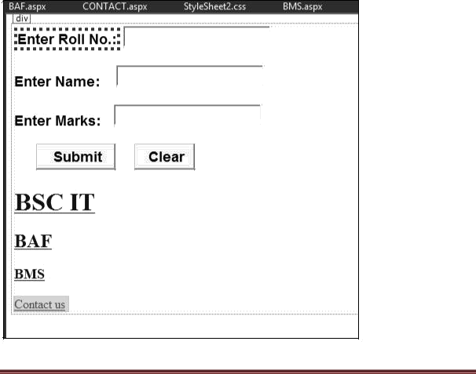**OUTPUT:**

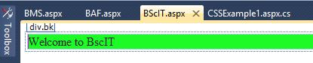

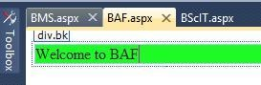

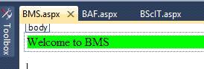

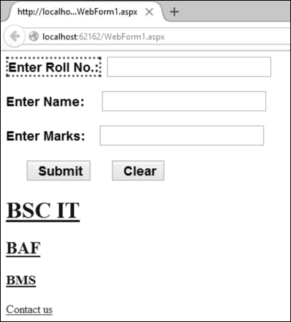

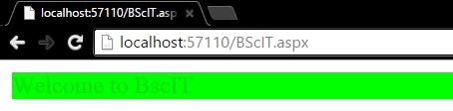

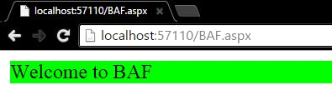



# PRACTICAL NO. : 04(4)

**AIM**: Change the font family and color of all heading of above webpage using css.

**DESIGN:**

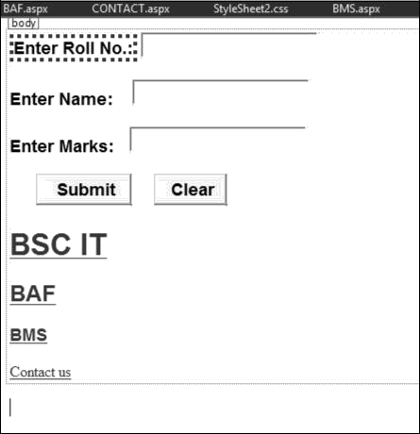

**CODE:**

## myformating.aspx

<%@ Page Language="C#" AutoEventWireup="true" CodeBehind="myformatting.aspx.cs" Inherits="WebApplication1.myformatting" %>

<!DOCTYPE html PUBLIC "-//W3C//DTD XHTML 1.0 Transitional//EN" "<http://www.w3.org/TR/xhtml1/DTD/xhtml1-transitional.dtd>">

<html xmlns="<http://www.w3.org/1999/xhtml>">

<head runat="server">

<title></title>

<link rel="Stylesheet" type="text/css" href="MyFormat.css"

/> <style type="text/css"> h1,h2,h3{color:Blue; font-family:Agency FB;}

</style>

</head>

<body>

<form id="form1" runat="server">

<div>

<asp:Label ID="Label1" runat="server" Text="Enter Roll No.:" BorderStyle="Dotted" BackColor="Coral"></asp:Label>

<asp:TextBox ID="TextBox1" runat="server" CssClass="TxtStyle"></asp:TextBox>

<br />

<asp:Label ID="Label2" runat="server" Text="Enter Name:" CssClass="Common"></asp:Label>

<asp:TextBox ID="TextBox2" runat="server" CssClass="TxtStyle"></asp:TextBox> <br />

<asp:Label ID="Label3" runat="server" Text="Enter Marks:" CssClass="Common"></asp:Label>

<asp:TextBox ID="TextBox3" runat="server" CssClass="TxtStyle"></asp:TextBox>

<br />

<br />

<asp:Button ID="Button1" runat="server" Text="Submit" CssClass="BtnStyle"

/> <asp:Button ID="Button2" runat="server" Text="Clear" CssClass="BtnStyle"

/> <h1><a href="bscit.aspx"</a>Bsc IT</h1> <h2><a href

="baf.aspx"</a>BAF</h2>

<h3><a href ="bms.aspx"</a>BMS</h3>

<a href="<http://www.vsit.edu.in/>"> Contact us</a>

<br />

<br />

<br />

<br />

</div>

</form>

</body>

</html>

**BROWSER OUTPUT:**

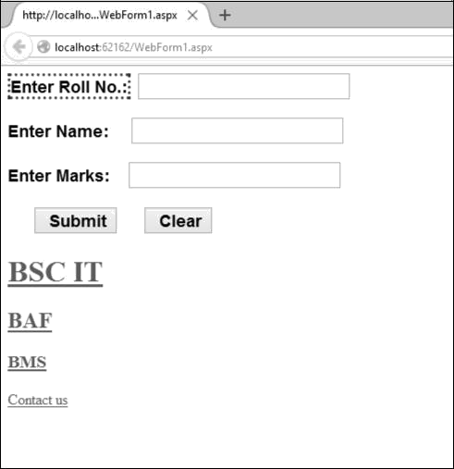

# PRACTICAL NO. : 04(5)

**AIM**: Use pseudo classes and display link, visited link and active link of contact us differently.

**DESIGN:**

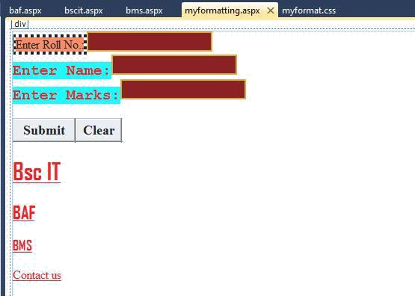

**CODE:**

## myformatting.aspx

<%@ Page Language="C#" AutoEventWireup="true" CodeBehind="myformatting.aspx.cs" Inherits="WebApplication1.myformatting" %>

<!DOCTYPE html PUBLIC "-//W3C//DTD XHTML 1.0 Transitional//EN" "<http://www.w3.org/TR/xhtml1/DTD/xhtml1-transitional.dtd>">

<html xmlns="<http://www.w3.org/1999/xhtml>">

<head runat="server">

<title></title>

<link rel="Stylesheet" type="text/css" href="MyFormat.css"

/> <style type="text/css"> h1,h2,h3{color:Blue; font-family:Agency FB;} A:link{color:Red;}

A:visited{color:Green;} A:active{color:Orange;}

</style>

</head>

<body>

<form id="form1" runat="server">

<div>

<asp:Label ID="Label1" runat="server" Text="Enter Roll No.:" BorderStyle="Dotted" BackColor="Coral"></asp:Label>

<asp:TextBox ID="TextBox1" runat="server" CssClass="TxtStyle"></asp:TextBox> <br />

<asp:Label ID="Label2" runat="server" Text="Enter Name:" CssClass="Common"></asp:Label>

<asp:TextBox ID="TextBox2" runat="server" CssClass="TxtStyle"></asp:TextBox> <br />

<asp:Label ID="Label3" runat="server" Text="Enter Marks:" CssClass="Common"></asp:Label>

<asp:TextBox ID="TextBox3" runat="server" CssClass="TxtStyle"></asp:TextBox> <br /><br />

<asp:Button ID="Button1" runat="server" Text="Submit" CssClass="BtnStyle"

/> <asp:Button ID="Button2" runat="server" Text="Clear" CssClass="BtnStyle"

/> <h1><a href="bscit.aspx"</a>Bsc IT</h1> <h2><a href

="baf.aspx"</a>BAF</h2>

<h3><a href ="bms.aspx"</a>BMS</h3>

<a href="<http://www.vsit.edu.in/>"> Contact us</a>

<br /><br /><br /><br />

</div>

</form>

</body>

</html>

**BROWSER OUTPUT:**

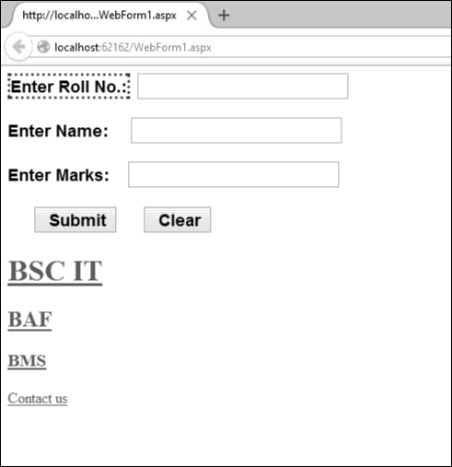

# PRACTICAL NO. : 05(1)

**AIM:** Programs using ASP.NET Server controls.

Create the application that accepts name, password ,age , email id, and user id. Allthe information entry is compulsory. Password should be reconfirmed. Age should be within 21 to 30. Email id should be valid. User id should have at least a capital letter and digit as well as length should be between 7 and 20 characters.

**DESIGN:**

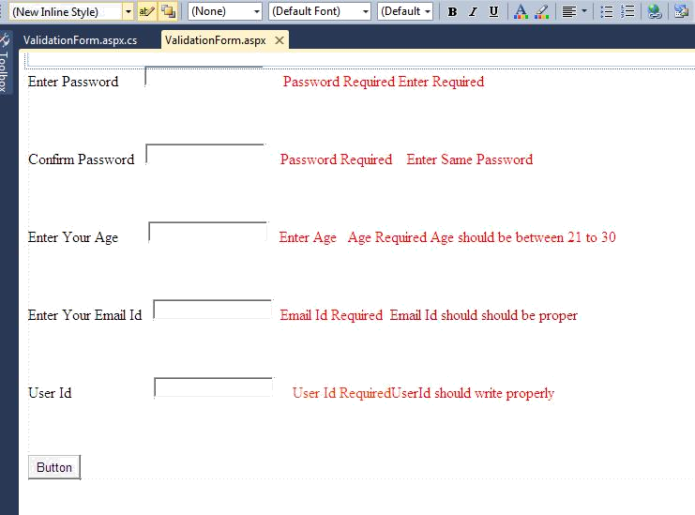

**CODE:**

## ValidateControlForm.aspx

using System;

using System.Collections.Generic; using System.Linq;

using System.Web; using System.Web.UI;

using System.Web.UI.WebControls; namespace ValidationControl

{

public partial class ValidationControlForm : System.Web.UI.Page

{

protected void Page_Load(object sender, EventArgs e)

{

}

protected void CustomValidator1_ServerValidate(object source, ServerValidateEventArgs args)

{

string str = args.Value; args.IsValid = false;

if (str.Length < 7 || str.Length > 20)

{

return;

}

bool capital = false; foreach (char ch in str)

{

if (ch >= 'A' && ch <= 'Z')

{

capital = true; break;

}

}

if (!capital) return;

bool digit = false; foreach (char ch in str)

{

if (ch >= '0' && ch <= '9')

{

digit = true; break;

}

}

if (!digit) return;

args.IsValid = true;

}

protected void btnSubmit_Click(object sender, EventArgs e)

{

}

} }

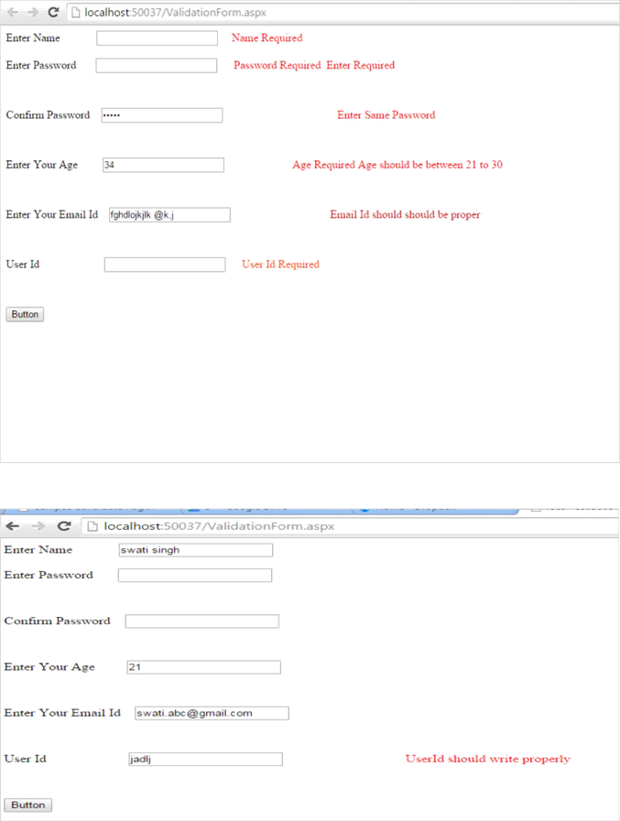**OUTPUT:**

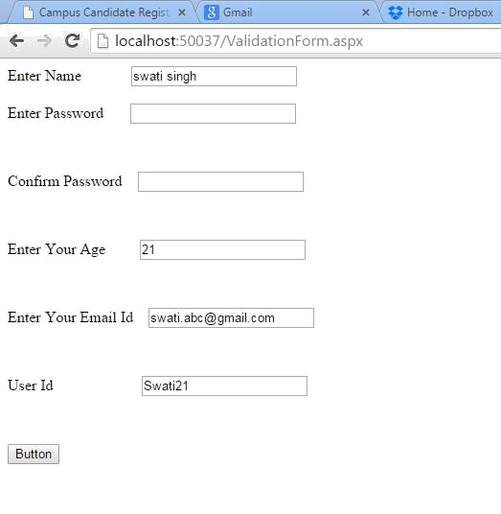

# PRACTICAL NO. : 05(2)

**AIM:** Programs using ASP.NET Server controls.

Create a website for a bank and include types of navigation.

**DESIGN:**

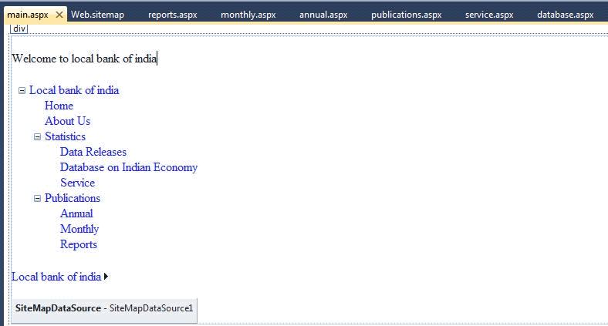

**CODE:**

## Web.sitemap

<?xml version="1.0" encoding="utf-8" ?>

<siteMap xmlns="<http://schemas.microsoft.com/AspNet/SiteMap-File-1.0>" >

<siteMapNode url="~\" title="Local bank of india" description="Online Banking">

<siteMapNode url="default.aspx" title="Home" description="Go to the homepage"

/> <siteMapNode url="about.aspx" title="About Us" description="About us"/>

<siteMapNode url="statistics.aspx" title="Statistics" description="Statistics">

<siteMapNode url="data.aspx" title="Data Releases" description="Data Releases"/>

<siteMapNode url="database.aspx" title="Database on Indian Economy" description="Economy of India"/>

<siteMapNode url="service.aspx" title="Service" description="Service Information"/>

</siteMapNode>

<siteMapNode url="publications.aspx" title="Publications" description="Publications"> <siteMapNode url="annual.aspx" title="Annual" description="Annual"/> <siteMapNode url="monthly.aspx" title="Monthly" description="Monthly"/> <siteMapNode url="reports.aspx" title="Reports" description="Reports"/> </siteMapNode>

</siteMapNode>

</siteMap>

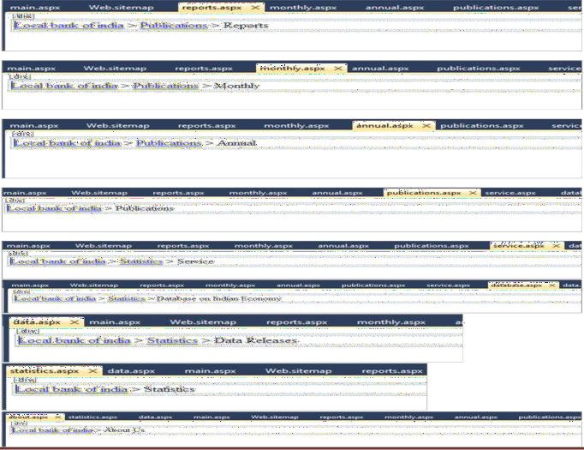**OUTPUT: (sitemap)**

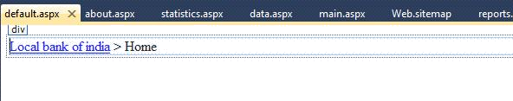

**OUTPUT: (Website form Tree view Controls)**

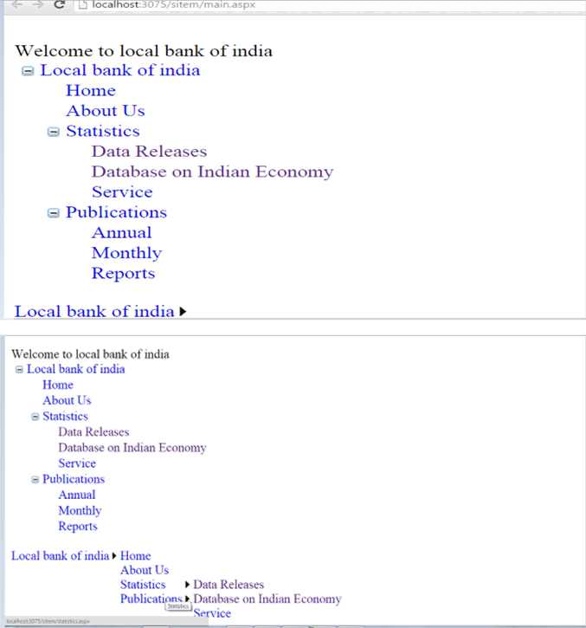

# PRACTICAL NO. : 06(1)

**AIM:** Database programs with ASP.NET and ADO.NET.

Create a Web App to display all the Empname and Deptid of the employee from the database using SQL source control and bind it to GridView . Database fields are(DeptId, DeptName, EmpName, Salary).

## Steps:

→ → → → →1. Fil ne website empty website name it ok

e w

→ → → → →Right click on website ma dd new item ql server databas me it dd es

2.

de a s e na a y

1. → → →

Right click on table In server explorer

1. Right click on table made →

add new table

→

add columns

save the table

1. →

show table data

→

add values

→

Right click on website

1. Go to design view

add new item

webform

name it

1. Add a gridview 8.

→

below that add sqldatasource

→

Configure sqldatasource

then add it to the gridview

1. Go to gridview menu enable sorting

**DESIGN:**

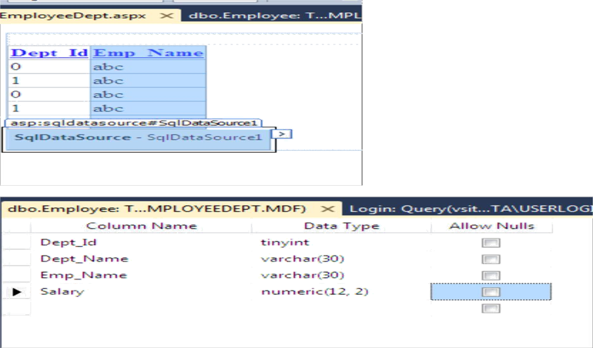

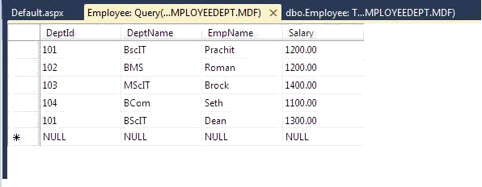

**OUTPUT:**

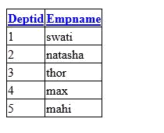

# PRACTICAL NO. : 06(2)

**AIM:** Database programs with ASP.NET and ADO.NET

Create a Login Module which adds Username and Password in the database. Username in the database should be a primary key.

## Steps2:

→ → → → →1. Fil ne website empty website name it ok

e w

→ → → → →Right click on website ma dd new item ql server databas me it dd es

2.

de a s e na a y

1. → → →

Right click on table In server explorer

1. Right click on table made →

add new table

→

add columns

save the table

1. →

show table data

→

add values

→

Right click on website

1. →

add new item

webform

name it

Go to design view

add form for login

→

Add sqldatasource

1. Write code

**DESIGN:**

configure it

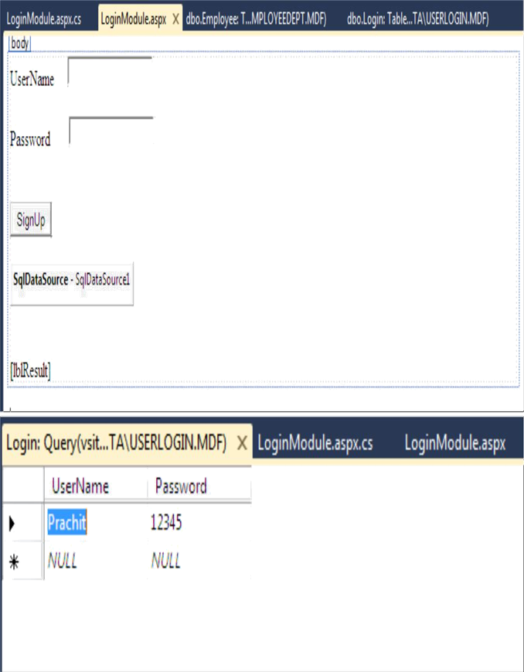

**CODE:**

## LoginModule.aspx

using System;

using System.Collections.Generic; using System.Linq;

using System.Web;

using System.Web.UI;

using System.Web.UI.WebControls;

public partial class LoginModule : System.Web.UI.Page

{

protected void Page_Load(object sender, EventArgs e)

{

}

protected void btnSignUp_Click(object sender, EventArgs e)

{

SqlDataSource1.InsertParameters["Username"].DefaultValue = txtUserName.Text; SqlDataSource1.InsertParameters["Password"].DefaultValue = txtPassword.Text;

SqlDataSource1.Insert(); lblResult.Text = "User Added";

}

}

**OUTPUT:**

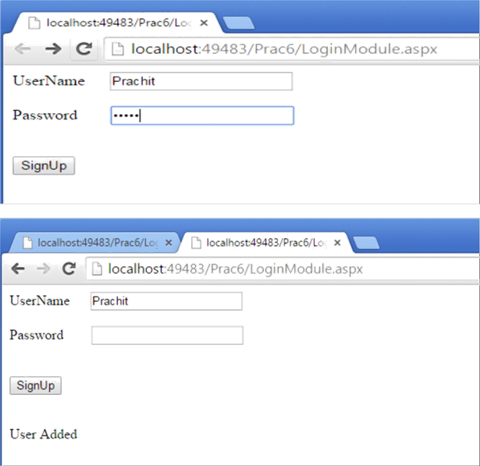

# PRACTICAL NO. : 06(3)

**AIM:** Database programs with ASP.NET and ADO.NET

Create a web application to insert 3 records inside the SQL database table having following fields( DeptId, DeptName, EmpName, Salary). Update the salary for any one employee and increment it to 15% of the present salary. Perform delete operation on 1 row of the database table.

## Steps:

9. → → → → →

File

new

website

empty website

name it

ok

→ → → → →

1. Right click on website made add new item sql server database name it add yes

→ → →

1. Right click on table In server explorer
2. Right click on table made →

add new table

→

add columns

save the table

show table data

→ →

add values

→

1. Right click on website

→

add new item

webform

name it

1. Go to design view

add necessary form

→

1. Add a grid view below the form

→

below that add sqldatasource

1. Configure sqldatasource then add it to the gridview

→ → → →

1. Go to grid view menu add columns select command field check on delete and edit ok

→

10.Double click on button write code.

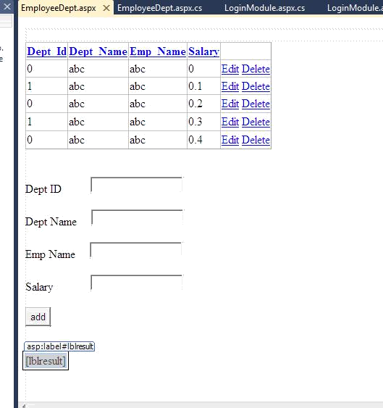**DESIGN:**

**CODE:**

using System;

using System.Collections.Generic; using System.Linq;

using System.Web; using System.Web.UI;

using System.Web.UI.WebControls;

public partial class LoginModule : System.Web.UI.Page

{

protected void Page_Load(object sender, EventArgs e)

{

}

protected void btnSignUp_Click(object sender, EventArgs e)

{

SqlDataSource1.InsertParameters["Username"].DefaultValue = txtUserName.Text; SqlDataSource1.InsertParameters["Password"].DefaultValue = txtPassword.Text;

SqlDataSource1.Insert(); Textbox1.Text=”‟;

Textbox2.Text=”‟;

}

}

**OUTPUT:**

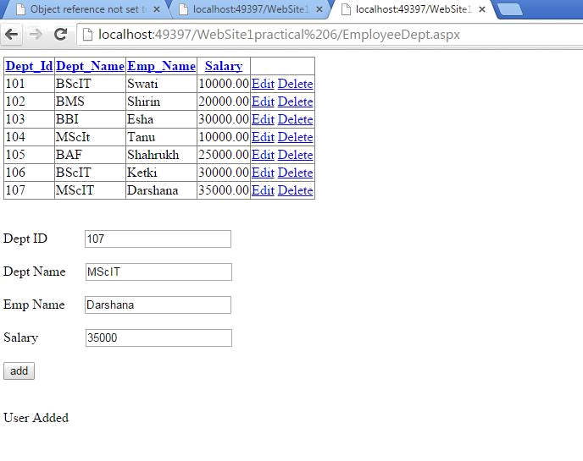

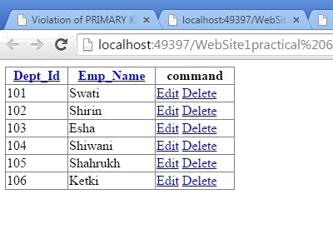

# PRACTICAL NO. : 07(1)

**AIM:** Programs using Language Integrated query. Create the table with the given fields.

FIELD NAME DATA TYPE EmpNo number EmpName varchar EmpSal number EmpJob varchar EmpDeptNo number

For the given table design a web page to display the employee information from table to grid control. Use LINQ TO ADO.NET.

**STEPS:**

→ → → → →

1. File new Website Empty Website name it

Add

1. Right click on website on solution explorer→ →

→

database

name it

→

add

→

yes

Add new item

Sql server

1. Server Explorer

→ →

table

→

right click

→

add new table

enter the columns

→

save the

table

1. Server explorer

→

right click on table which is made

→ →

show table data

add values

1. Server explorer

→

right click on website created

→

→

add new item

→

web form

→

name it

1. Go to design view of aspx page

Double click on aspx page.

**DESIGN:**

add grid view from toolbox.

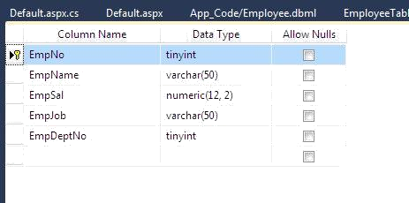

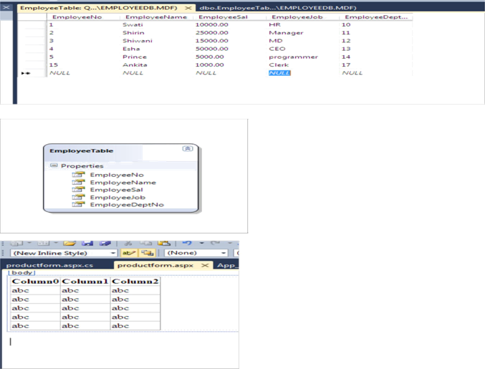

**CODE:**

## Default.aspx.cs

using System;

using System.Collections.Generic; using System.Linq;

using System.Web; using System.Web.UI; using System.Data.Linq;

using System.Data.SqlClient;

using System.Web.UI.WebControls;

public partial class _Default : System.Web.UI.Page

{

protected void Page_Load(object sender, EventArgs e)

{

EmployeeDataContext dc = new EmployeeDataContext(); var query = from m in dc.EmployeeTables select m;

GridView1.DataSource = query; GridView1.DataBind();

}

}

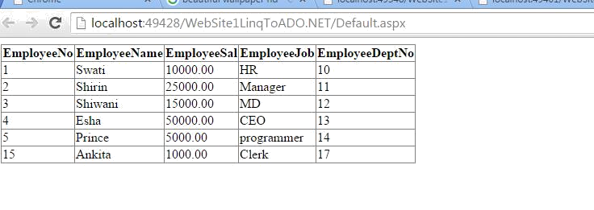**OUTPUT:**

# PRACTICAL NO. : 07(2)

**AIM:** Programs using Language Integrated query. Create the table with the given fields.

FIELD NAME DATA TYPE SRollno int SName string SAddress string SFees int

For the given table design a web page to display the employee information from table to grid control. Use LINQ TO XML.

**STEPS:**

→ → → →

1. File New website Empty Website name it

→ → → → → →

1. Solution Explorer

right click on website made add new item XML file name it add write code

→ → → → →

1. Solution explorer right click on website add new item webform name it add

→

→

1. Go to design view

**DESIGN:**

double click page

write code.

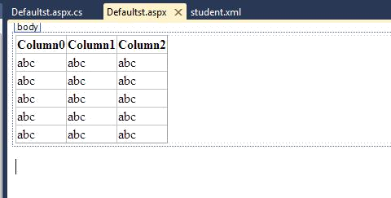

**CODE:**

## student.xml

<?xml version="1.0" encoding="utf-8" ?>

<TYStudents>

<student>

<srollno>1</srollno>

<sname>swati</sname>

<saddress>Wadala</saddress>

<sfees>1000</sfees>

</student>

<student>

<srollno>2</srollno>

<sname>natasha</sname>

<saddress>Dadar</saddress>

<sfees>3000</sfees>

</student>

</TYStudents>

## Defaultst.aspx.cs

using System;

using System.Collections.Generic; using System.Linq;

using System.Web; using System.Web.UI; using System.Xml.Linq;

using System.Web.UI.WebControls;

public partial class Defaultst : System.Web.UI.Page

{

protected void Page_Load(object sender, EventArgs e)

{

XDocument xmlDoc = XDocument.Load(HttpContext.Current.Server.MapPath("student.xml"));

var studs = from s in xmlDoc.Descendants("student") select s;

GridView1.DataSource = studs; GridView1.DataBind();

}

}

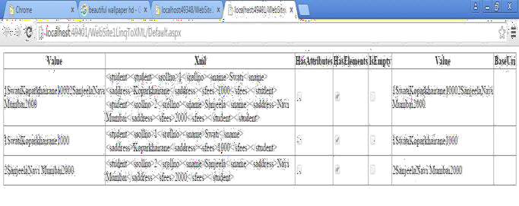**OUTPUT:**

# PRACTICAL NO. : 07(3)

**AIM:** Programs using Language Integrated query. Create the table with the given fields .

FIELD NAME DATA TYPE PID string PName

string PPrice int PWeight int

For the given table design a web page to display the employee information from table to grid control. Use LINQ TO Objects.

**STEPS:**

→

1. File

new

→

website

→

name it

→ → → → →

1. Solution explorer right click on website made class name it yes write code

→ → → → →

1. Solution explorer

right click on website

→

add new item

→

webform

name it

→

add

1. Go to design view

**DESIGN:**

add GridView

Double click on page

write code.

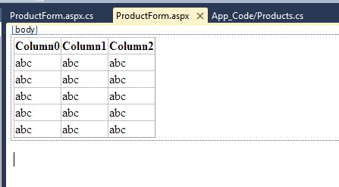

**CODE:**

## App_Code/Products.cs

using System;

using System.Collections.Generic; using System.Linq;

using System.Web; public class Products

{

public string PID { get; set; } public string PName { get; set; } public int PPrice { get; set; } public int PWeight { get; set; }

public Products()

{

} }

## ProductForm.aspx.cs

using System;

using System.Collections.Generic; using System.Linq;

using System.Web; using System.Web.UI;

using System.Web.UI.WebControls;

public partial class ProductForm : System.Web.UI.Page

{

public List<Products> GetProdData()

{

return new List<Products> {

new Products { PID="P101", PName="Laptop", PPrice=25000 , PWeight=1500}, new Products { PID="P102", PName="Desktop", PPrice=22000 , PWeight=8000}, new Products { PID="P103", PName="Mouse", PPrice=500 , PWeight=250}

};

}

protected void Page_Load(object sender, EventArgs e)

{

var prod = GetProdData(); var query = from f in prod

orderby f.PName select f;

this.GridView1.DataSource = query; this.GridView1.DataBind();

}

}

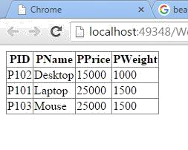**OUTPUT:**

# PRACTICAL NO. : 08

**AIM:** (A) For the web page created for the display OF Employee data change the authentication mode to Windows

**CODE:**

<system.web>

<authentication mode=”Windows”>

<forms loginUrl=”~/”Prac8/EmployeeForm.aspx”>

</authentication>

</system.web

## Steps for changing the authentication mode

1. Open the website created for displaying the Employee data
2. From the solution Explorer window open the web.config file

3 .In the web.config file search the <system.web> xml tag and in <system.web> xml tag go to authentication tag

4. Change the authentication mode to windows as given above.

**AIM:** (B) For the webpage created for the display of Student data change the authorization mode so that only users who have logged in as VSIT will have the authority to aces the page

**CODE:**

<system.web>

<authentication>

<allow users=”VSIT”/>

<deny users =” *”/>

</authentication>

</system.web>

## Steps for changing the authorization

1. Open the website created for displaying the Student data
2. From the solution Explorer window open the web.config file
3. In the Web.config file search the <system.web> xml tag and in <system.web> xml tag go to authentication tag
4. Change the coding in the tag as given above

# PRACTICAL NO: 9(A)

**AIM:** Create a web page to display the news from the news table(id, news_dtl). Use AJAX.

**DESIGN :**

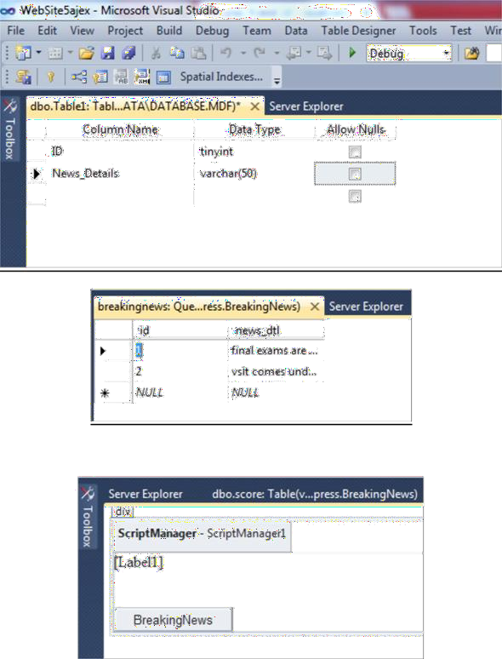

**CODE:**

using System; usingSystem.Collections.Generic; usingSystem.Linq; usingSystem.Web; usingSystem.Web.UI; usingSystem.Web.UI.WebControls; usingSystem.Data.SqlClient;

publicpartialclassajaxform : System.Web.UI.Page

{

protectedvoidPage_Load(object sender, EventArgs e)

{

}

protectedvoid Button1_Click(object sender, EventArgs e)

{

SqlConnection con = newSqlConnection(@"Data Source=.\sqlexpress;Initial Catalog=BreakingNews;Integrated Security=True"); con.Open();

SqlCommand com = newSqlCommand("select * from news", con); SqlDataReaderdr = com.ExecuteReader();

while (dr.Read())

{

Label1.Text +=dr[1].ToString()+"<br>";

}

con.Close();

}

}

**OUTPUT:**

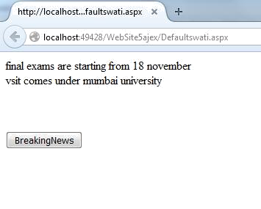

# PRACTICAL NO: 9(B)

**AIM**: In the above website also display the feedback on the browser as “work is in progress”.

**DESIGN:**

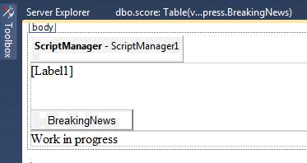

**CODE:**

using System; usingSystem.Collections.Generic; usingSystem.Linq; usingSystem.Web; usingSystem.Web.UI; usingSystem.Web.UI.WebControls; usingSystem.Data.SqlClient;

publicpartialclassajaxform : System.Web.UI.Page

{

protectedvoidPage_Load(object sender, EventArgs e)

{

System.Threading.Thread.Sleep(5000);

}

protectedvoid Button1_Click(object sender, EventArgs e)

{

SqlConnection con = newSqlConnection(@"Data Source=.\sqlexpress;Initial Catalog=BreakingNews;Integrated Security=True"); con.Open();

SqlCommand com = newSqlCommand("select * from news", con); SqlDataReaderdr = com.ExecuteReader();

while (dr.Read())

{

Label1.Text +=dr[1].ToString()+"<br>";

}

con.Close();

}

}

# Source Code:

<%@PageLanguage="C#"AutoEventWireup="true"CodeFile="ajaxform.aspx.cs"Inherits="aj axform"%>

<!DOCTYPEhtmlPUBLIC"-//W3C//DTD XHTML 1.0

Transitional//EN""<http://www.w3.org/TR/xhtml1/DTD/xhtml1-transitional.dtd>">

<htmlxmlns="<http://www.w3.org/1999/xhtml>">

<headrunat="server">

<title></title>

</head>

<body>

<formid="form1"runat="server">

<div>

<asp:ScriptManagerID="ScriptManager1"runat="server">

</asp:ScriptManager>

<br/>

<asp:UpdatePanelID="UpdatePanel1"runat="server">

<ContentTemplate>

<asp:LabelID="Label1"runat="server"></asp:Label>

<br/>

<br/>

<asp:ButtonID="Button1"runat="server"Text="Breaking news"/>

<br/>

</ContentTemplate>

</asp:UpdatePanel>

<br/>

<br/>

<br/>

<asp:UpdateProgressID="UpdateProgress1"runat="server">

<ProgressTemplate>Work in progress</ProgressTemplate>

</asp:UpdateProgress>

<br/>

<br/>

</div>

</form>

</body>

</html>

# Output:

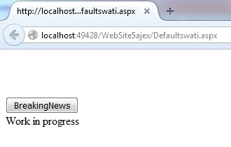

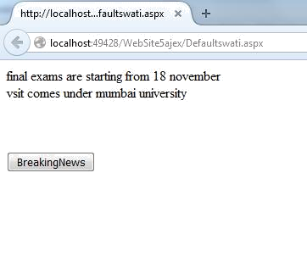

**PRACTICAL NO: 9(C)**

**AIM**: Create a web page to display the cricket score from the table event(id, name, score).

Refresh the website automatically after every 30 seconds.

**DESIGN:**

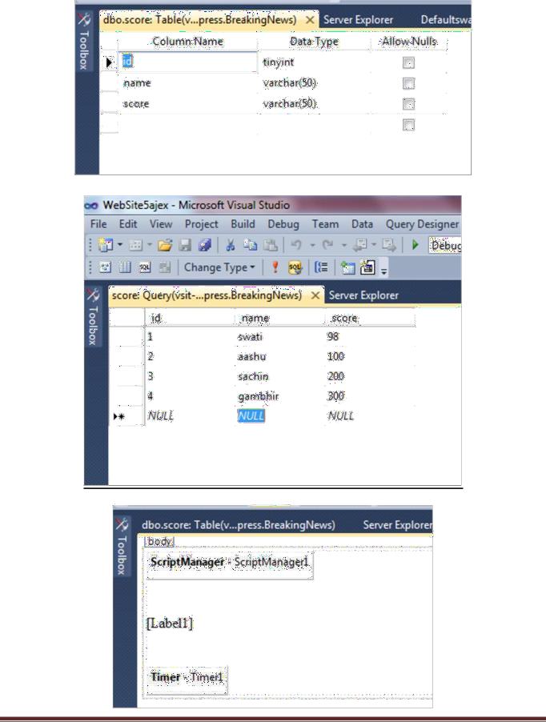

**CODE:**

## Default.aspx

using System;

using System.Collections.Generic; using System.Linq;

using System.Web; using System.Web.UI;

using System.Web.UI.WebControls; using System.Data.SqlClient;

public partial class Defaultswati1 : System.Web.UI.Page

{

protected void Page_Load(object sender, EventArgs e)

{

}

protected void Timer1_Tick(object sender, EventArgs e)

{

SqlConnection conn = new SqlConnection(@"Data Source=.\sqlexpress;Initial Catalog=BreakingNews;Integrated Security=True");

SqlDataReader dr = null;

conn.Open();

SqlCommand cmd = new SqlCommand("Select * from score", conn); dr = cmd.ExecuteReader();

while (dr.Read())

{

Label1.Text += dr[0].ToString() + " " + dr[1].ToString() + " " + dr[2].ToString()

+ "<br>";

}

conn.Close();

}

}

**OUTPUT:**

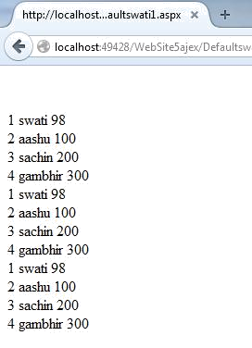

# PRACTICAL NO: 10(A)

**AIM:** Create a web page to give different color effects for paragraph tags, heading tags and complete web page using JQuery.

**DESIGN:**

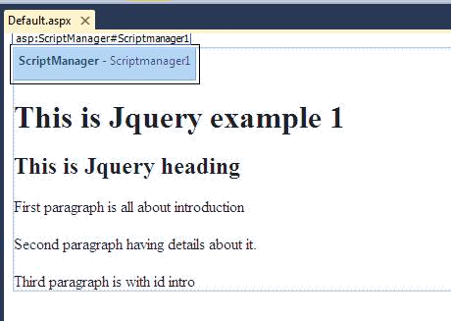

# Source Code:

<%@PageLanguage="C#"AutoEventWireup="true"CodeFile="Default.aspx.cs"Inherits="_D efault"%>

<!DOCTYPEhtmlPUBLIC"-//W3C//DTD XHTML 1.0

Transitional//EN""<http://www.w3.org/TR/xhtml1/DTD/xhtml1-transitional.dtd>">

<htmlxmlns="<http://www.w3.org/1999/xhtml>">

<headrunat="server">

<title></title>

</head>

<body>

<formid="form1"runat="server">

<div>

<scripttype="text/javascript">

$(document).ready(function () {

$("p").css("color", "Yellow");

$("h1,h2").css("color", "White");

$("p#intro").css("color", "Blue");

$("*").css("background-color", "Red");

});

</script>

<asp:ScriptManagerID="Scrpitmanager1"runat="server">

<Scripts>

<asp:ScriptReferencePath="~/scrpits/jquery-1.11.3.js"/>

</Scripts>

</asp:ScriptManager>

<h1>This is Jquery example</h1>

<h2>This is Jquery heading</h2>

<p>First paragraph is all about introduction</p>

<p>Second paragraph having details about it</p>

<pid="intro">Third paragraph is with id intro</p>

</div>

</form>

</body>

</html>

**OUTPUT:**

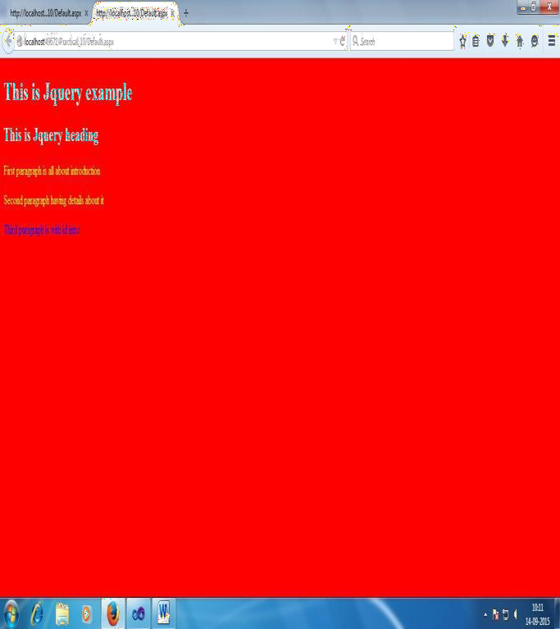

# PRACTICAL NO: 10(B)

**AIM:** Create a web page to display animation using JQuery.

**DESIGN:**

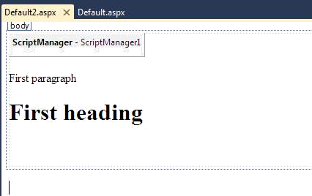

# Source Code:

<%@ Page Language="C#" AutoEventWireup="true" CodeFile="Default2.aspx.cs" Inherits="Default2" %>

<!DOCTYPE html PUBLIC "-//W3C//DTD XHTML 1.0 Transitional//EN" "<http://www.w3.org/TR/xhtml1/DTD/xhtml1-transitional.dtd>">

<html xmlns="<http://www.w3.org/1999/xhtml>">

<head runat="server">

<title></title>

</head>

<body>

<form id="form1" runat="server">

<div>

<script type="text/javascript"">

$(document).ready(function () {

$('p').hide(1000);

$('p').show(2000);

$('p').toggle(3000);

$('p').slideDown(4000);

$('p').slideUp(5000);

$('h1').animate({

opacity: 0.4, marginLeft: '50px', fontSize: '100px'

}, 8000);

});

</script>

<asp:ScriptManager ID="Scriptmanager1" runat="server">

<Scripts>

<asp:ScriptReference Path="~/Scripts/jquery-1.11.3.js" />

</Scripts>

</asp:ScriptManager>

<p>First Paragraph</p>

<h1>First Heading</h1>

</div>

</form>

</body>

</html>

**OUTPUT:**

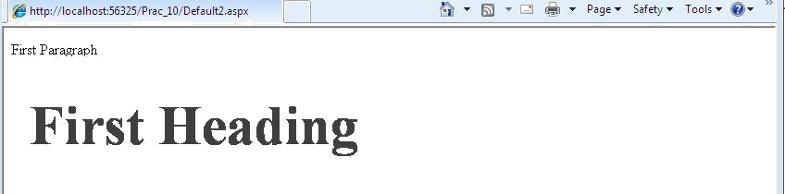

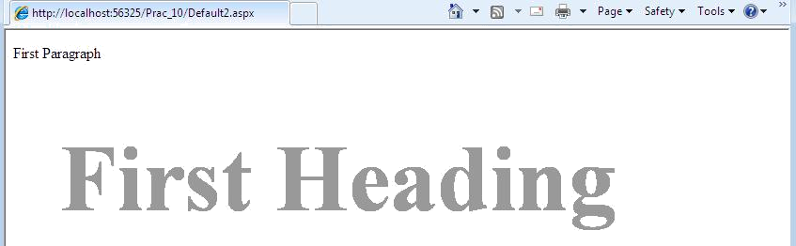

# PRACTICAL NO: 10(C)

**AIM:** Create a web page to display hide, show, slidedown, slideup and Toggle effects for paragraph tags, using JQuery.

**DESIGN:**

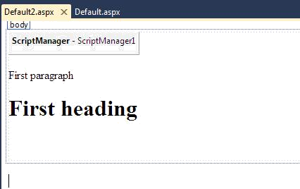

## Source Code: Default.aspx

<%@ Page Language="C#" AutoEventWireup="true" CodeFile="Default2.aspx.cs" Inherits="Default2" %>

<!DOCTYPE html PUBLIC "-//W3C//DTD XHTML 1.0 Transitional//EN" "<http://www.w3.org/TR/xhtml1/DTD/xhtml1-transitional.dtd>">

<html xmlns="<http://www.w3.org/1999/xhtml>">

<head runat="server">

<title></title>

</head>

<body>

<form id="form1" runat="server">

<div>

<script type="text/javascript">

$(document).ready(function(){

$('h1').animate({ opacity:

0.4,marginLeft:'50px',fontSize:'100px'},8000); });

</script>

<asp:ScriptManager ID="ScriptManager1" runat="server"> <Scripts>

<asp:ScriptReference Path="~/script/jquery-1.11.3.js" /></Scripts></asp:ScriptManager>

<p>First paragraph</p>

<h1>First heading heading</h1>

</div>

</form>

</body>

</html>

**OUTPUT:**

